|  |  |  |  |  |  |
| --- | --- | --- | --- | --- | --- |
| Date | 7-Dec-22 | | | Tester Name | Mohammad Yusuf |
| Environment | Penfax - Test | | | Login used |  |
| Operating System | Windows | Version: | Update: | | |
| Software Used | Select Software | Version: | Update: | | |
| Select Software | Version: | Update: | | |
| Release version |  | | | | |
| Title |  | | | | |
| Test Type | Regression | | | | |
| Test Scenario |  | | | | |
|  |  | | | | |
| Expected Results |  | | | | |
| Pass/Fail | Select | | | JIRA# | N/A |

Describe your steps with screenshots:   
MEPP Retired/Pensioned Member

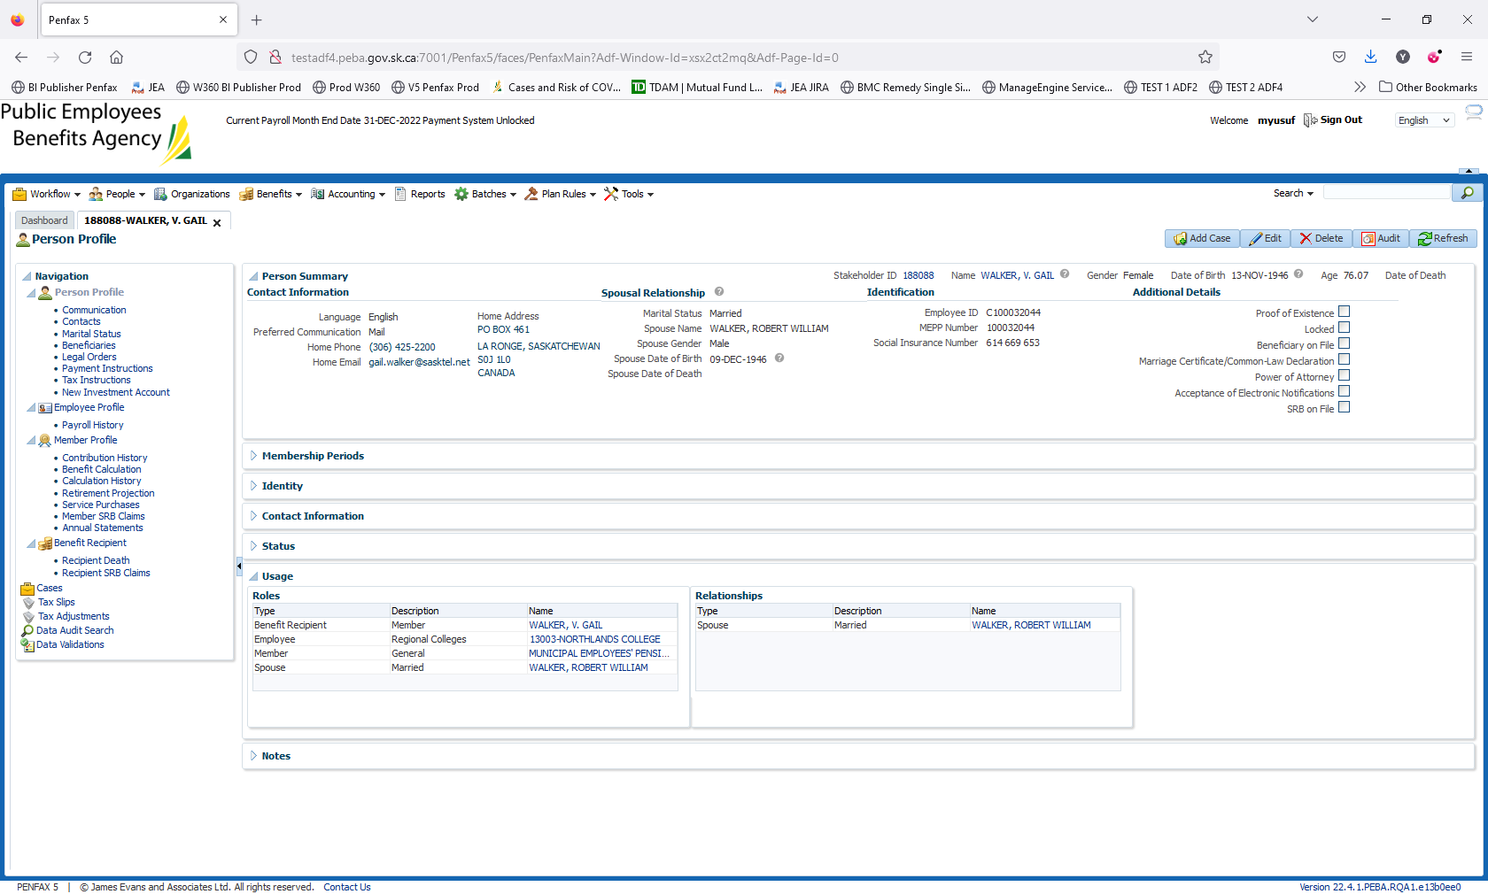

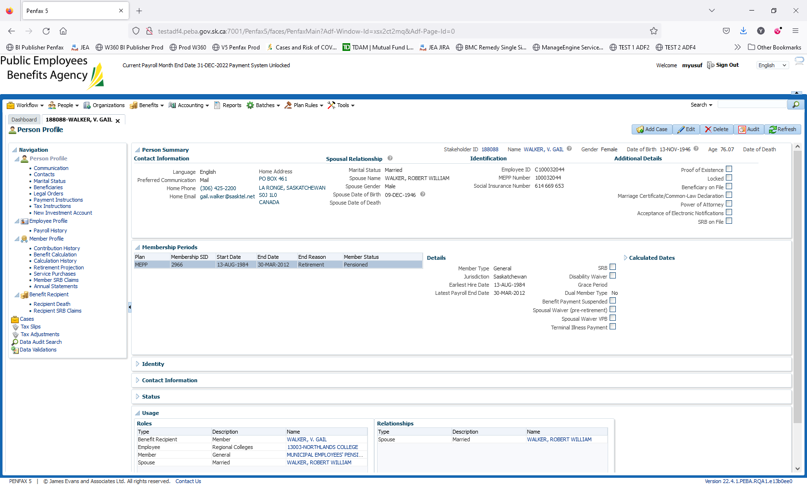

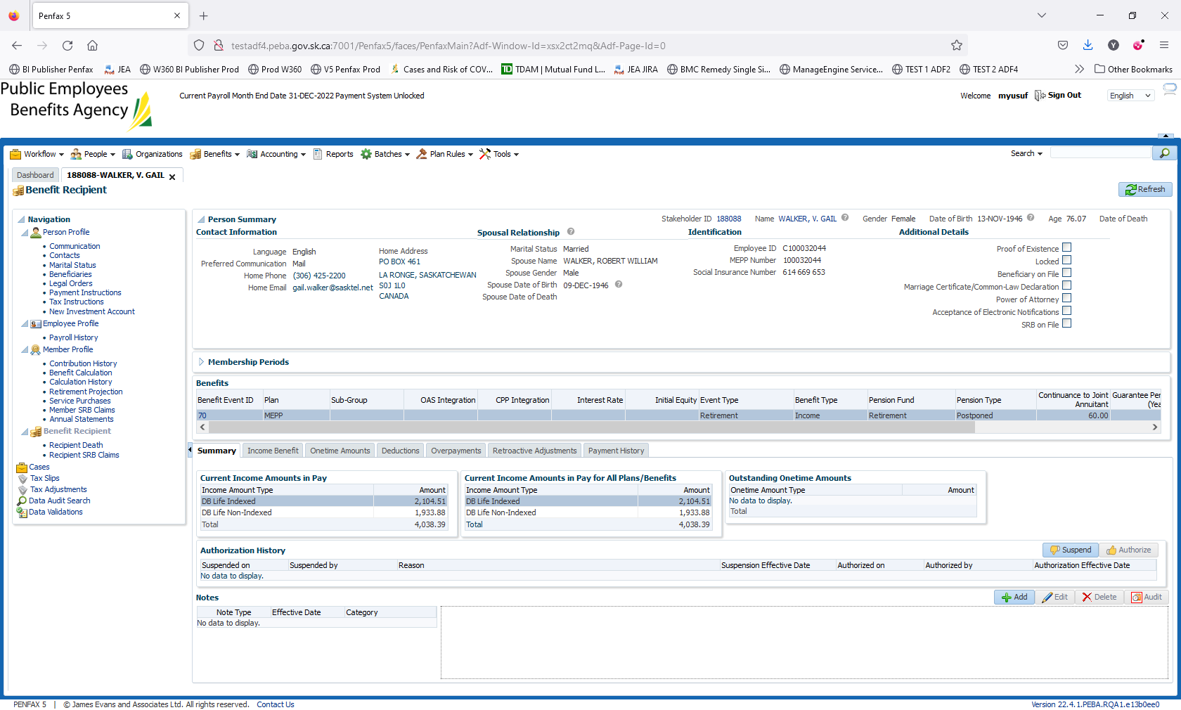

Before picture for Beneficiary Section

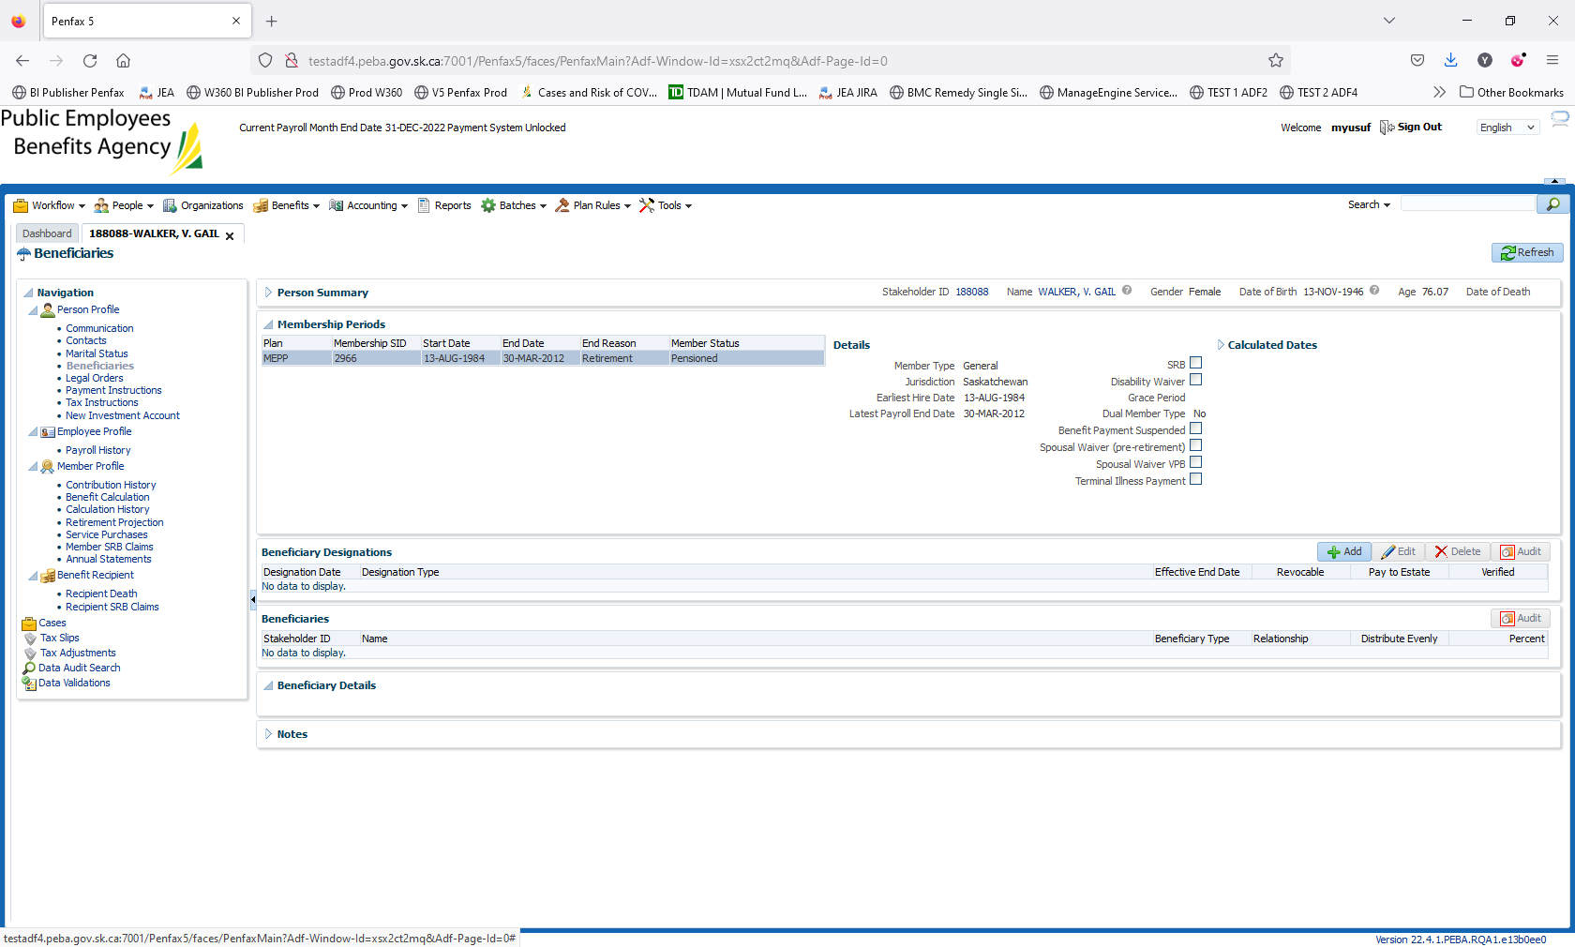

Enter the Date of Death. Person Profile -> Edit. Enter DOD 01 Dec 2022

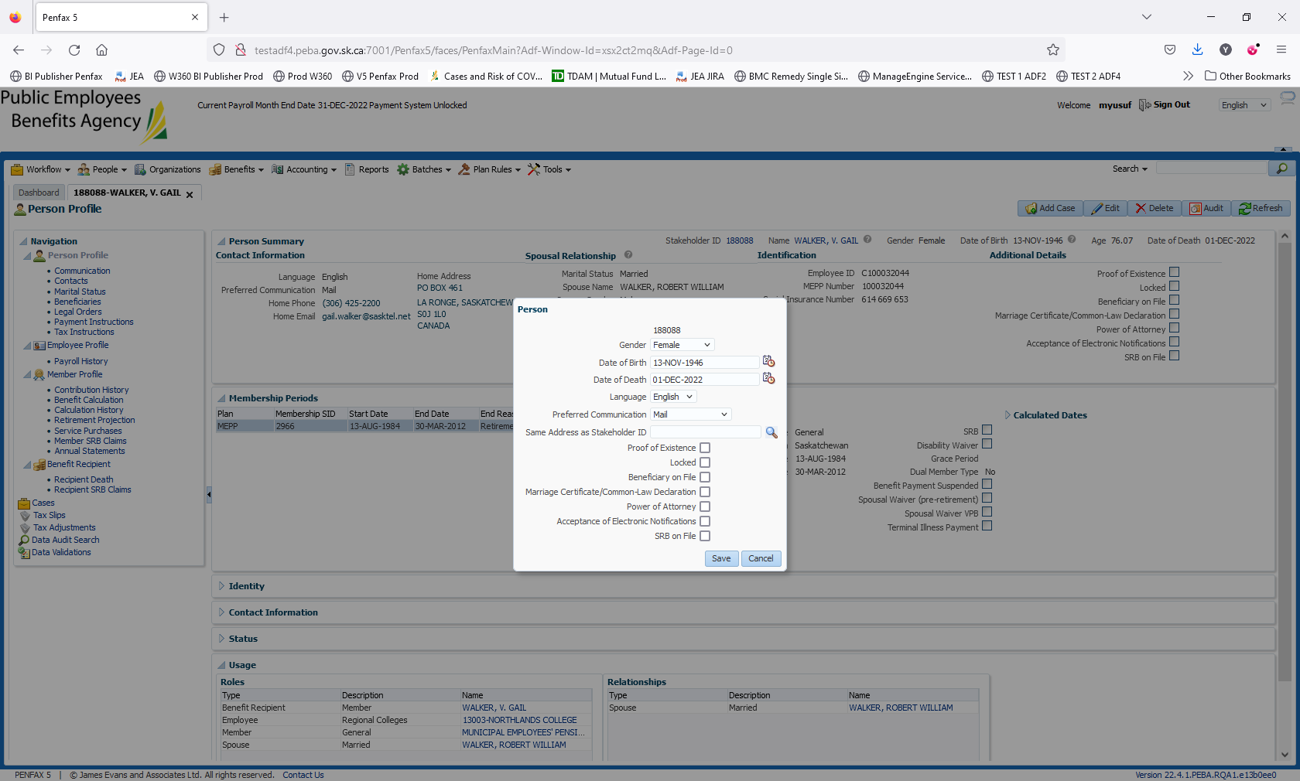

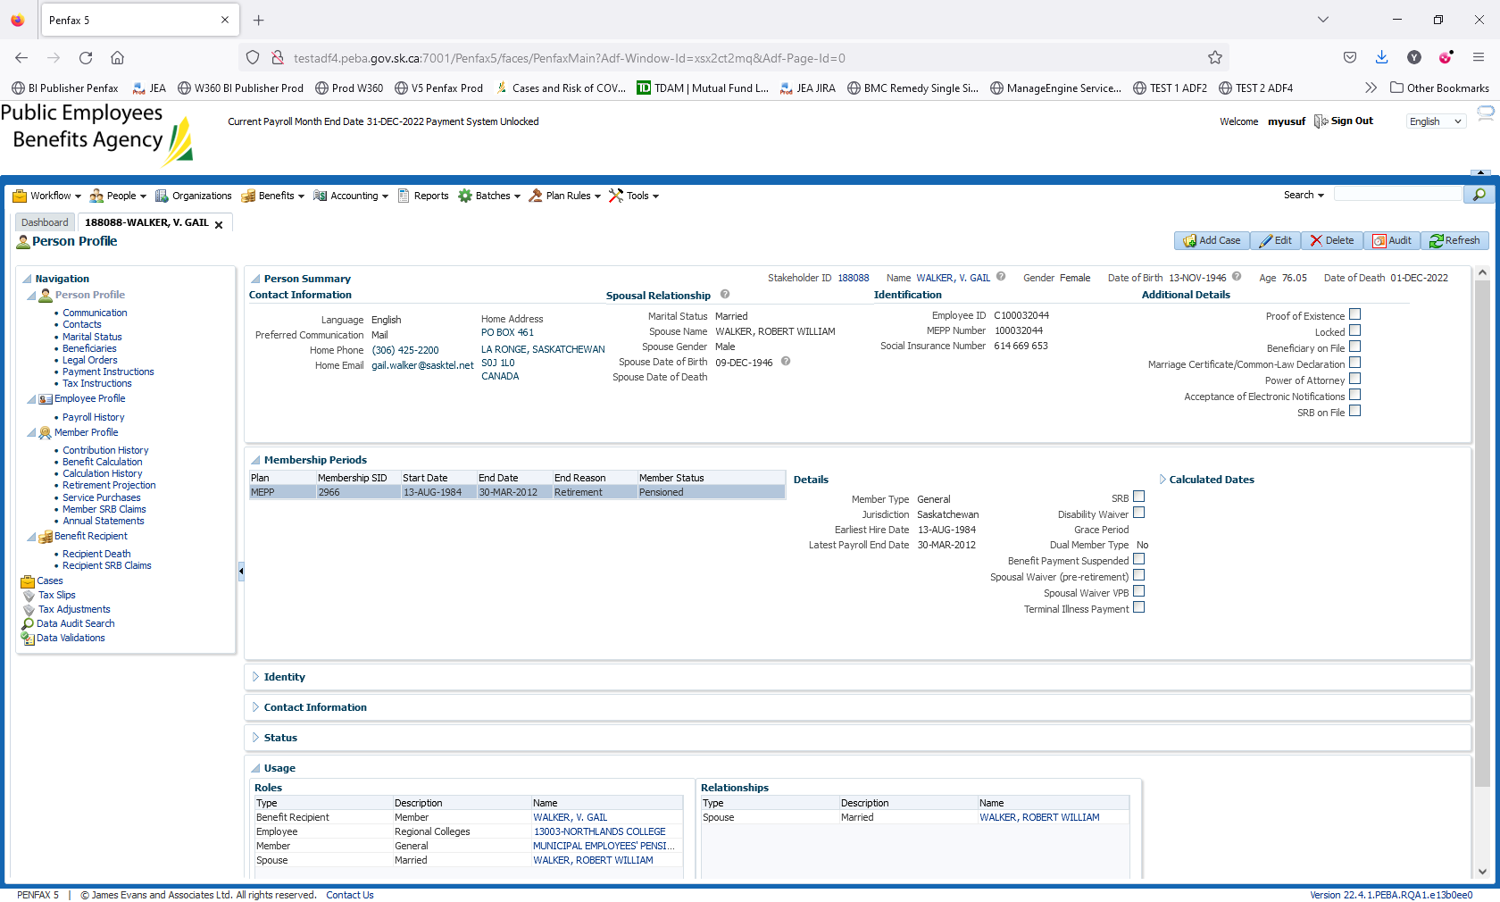

Click on Save

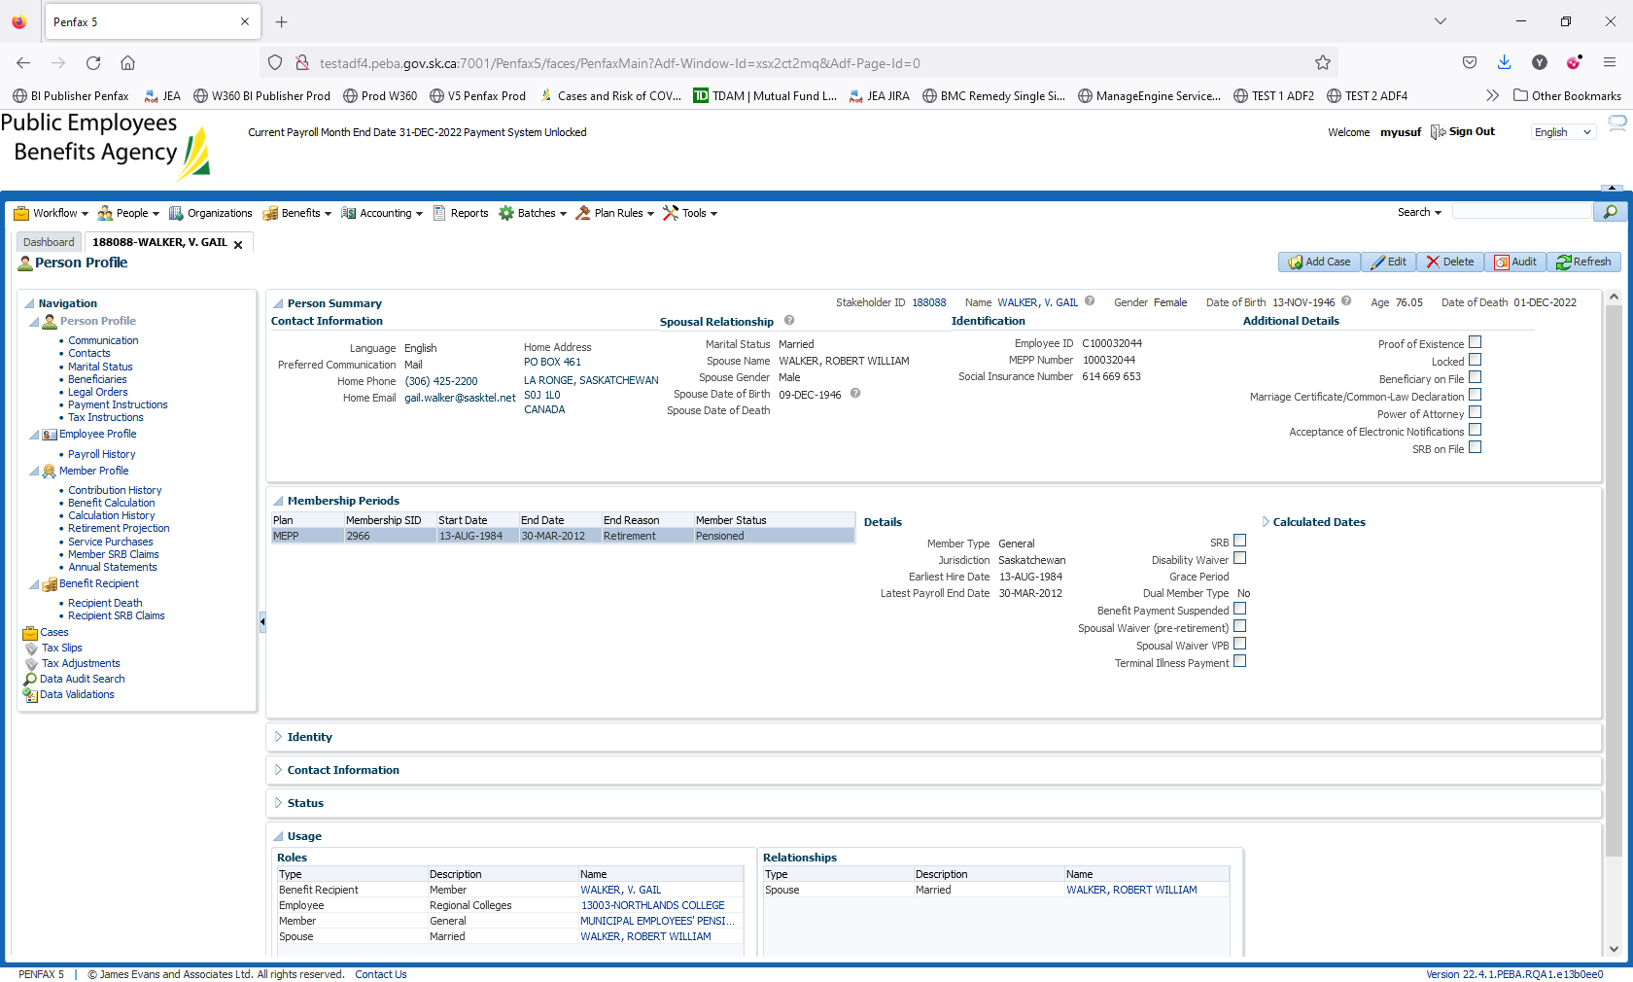

Run the Death Calculation. Go to Benefit Recipient -> Recipient Death

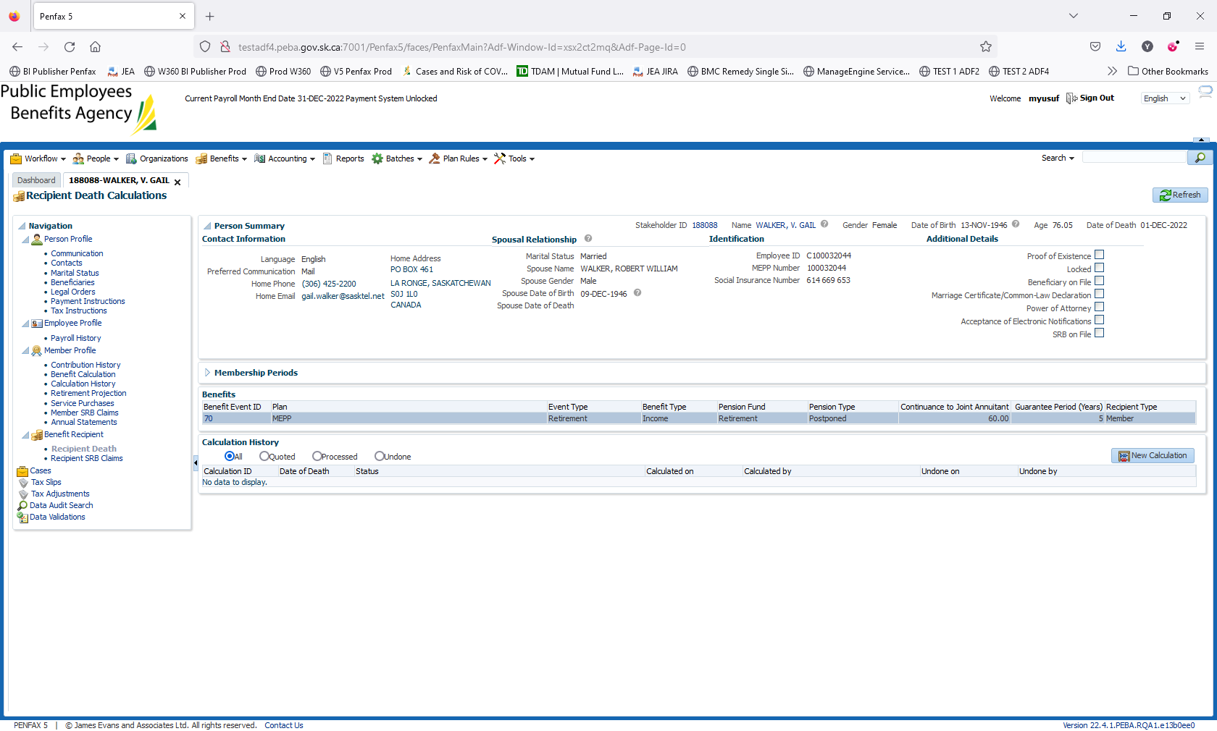

Click on New Calculation. Validate the DOD and click on Calculate

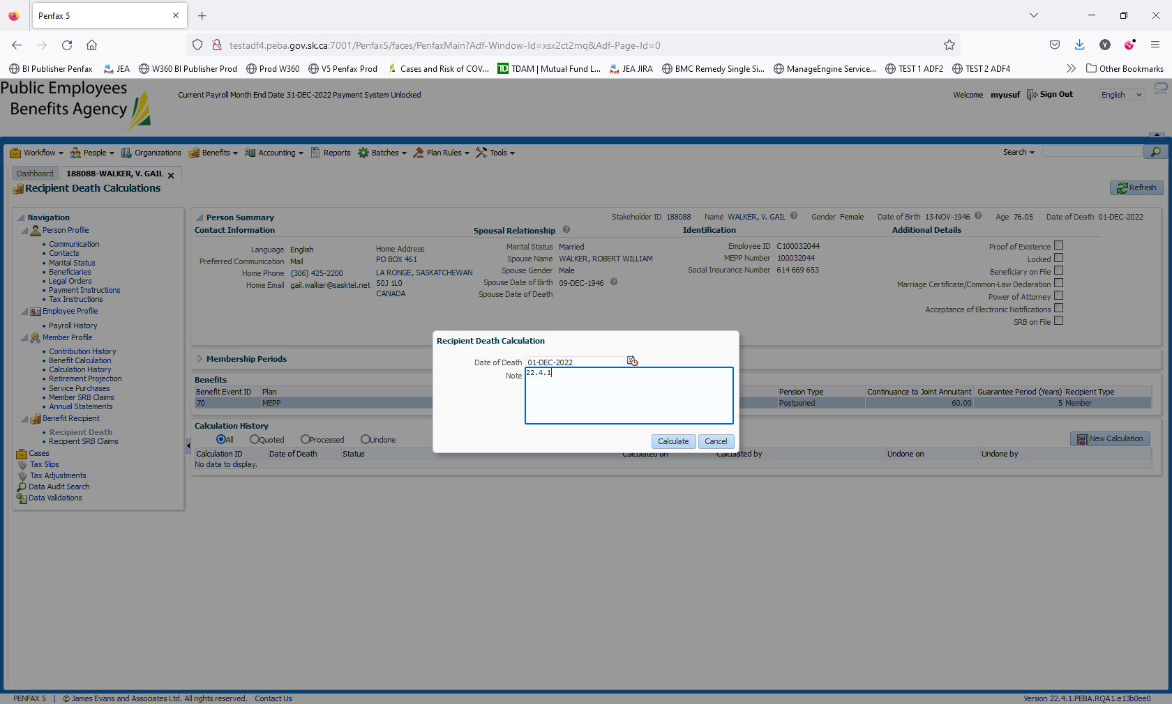

Click on Process – twice

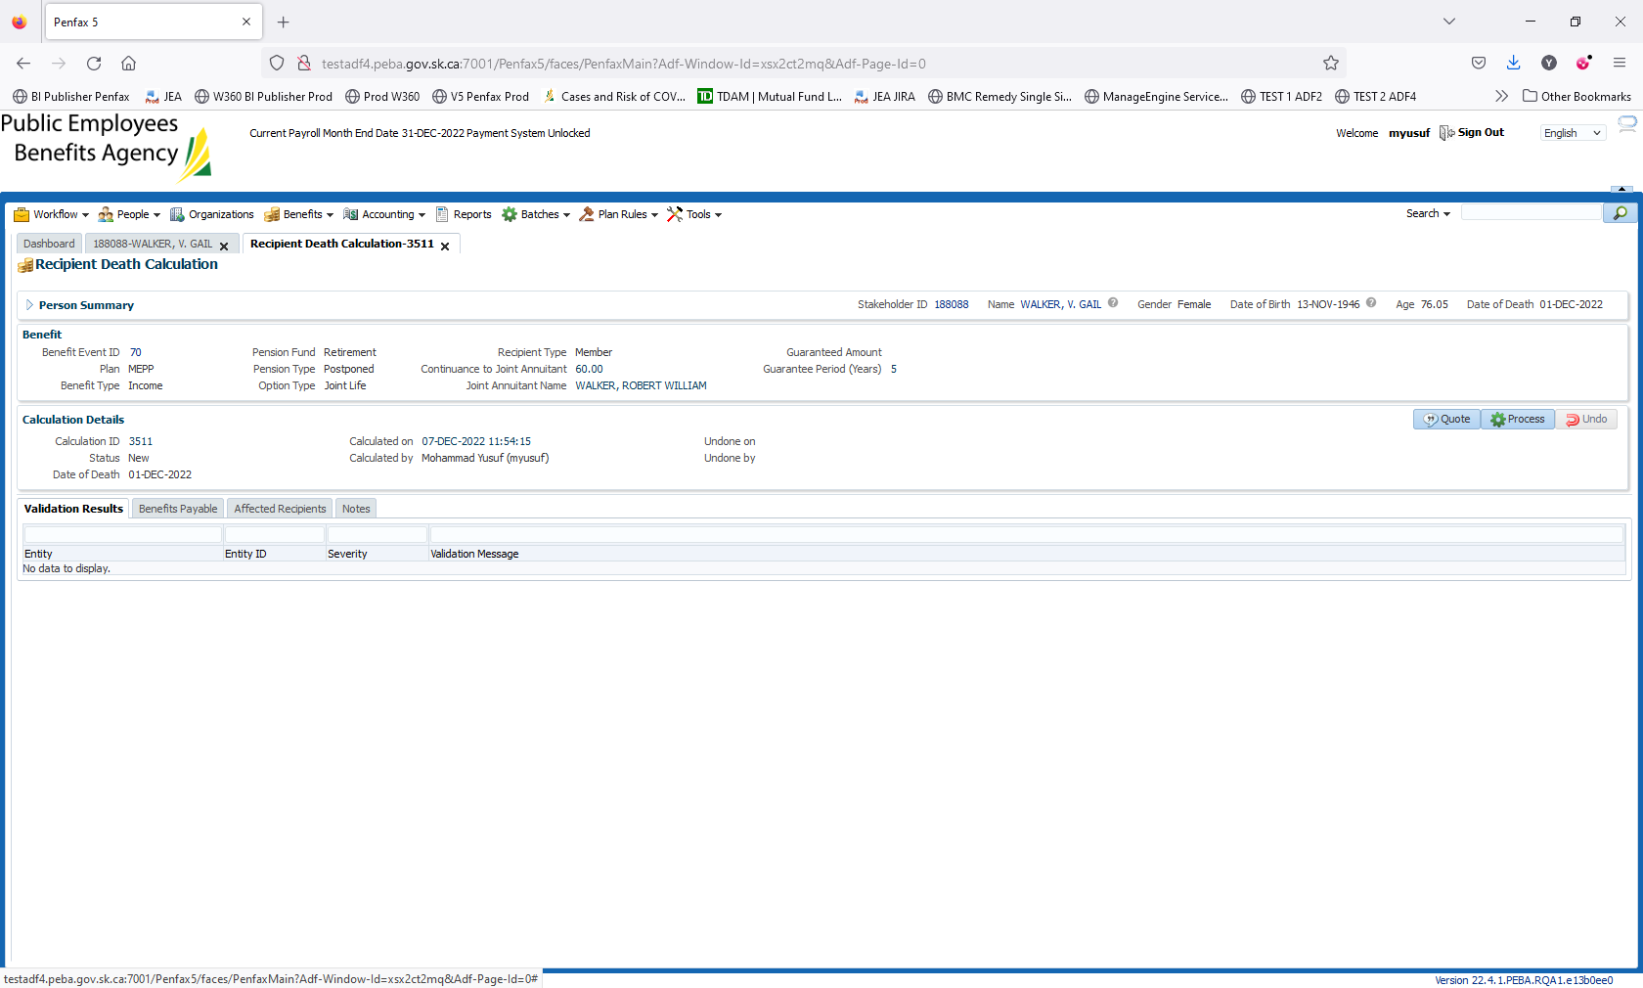

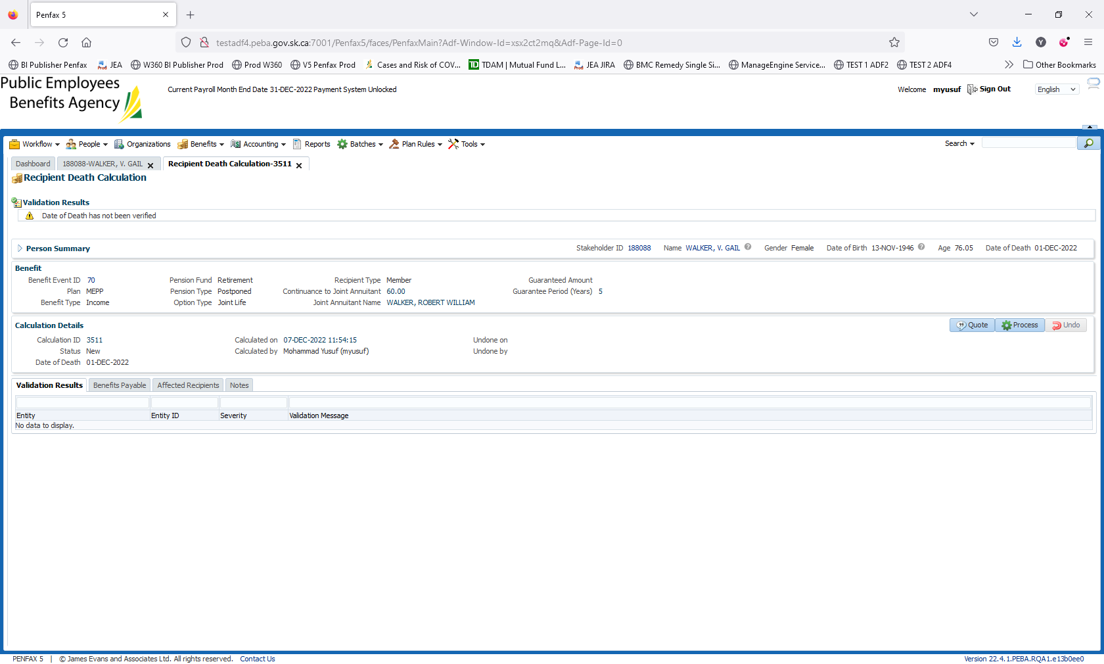

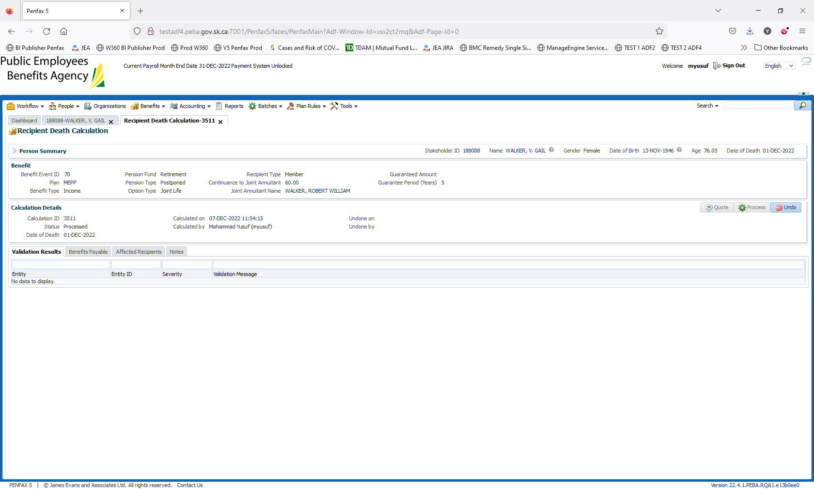

Navigate to Stakeholder 188088. Go to Person Profile -> Beneficiaries

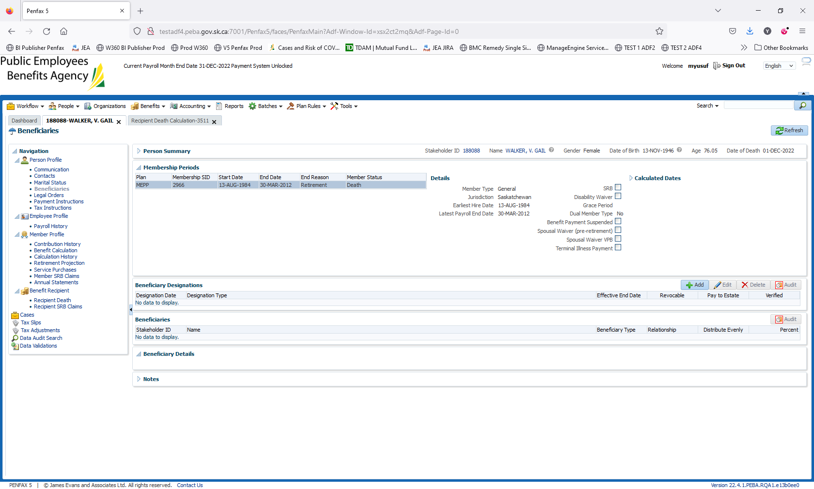

Click on Add

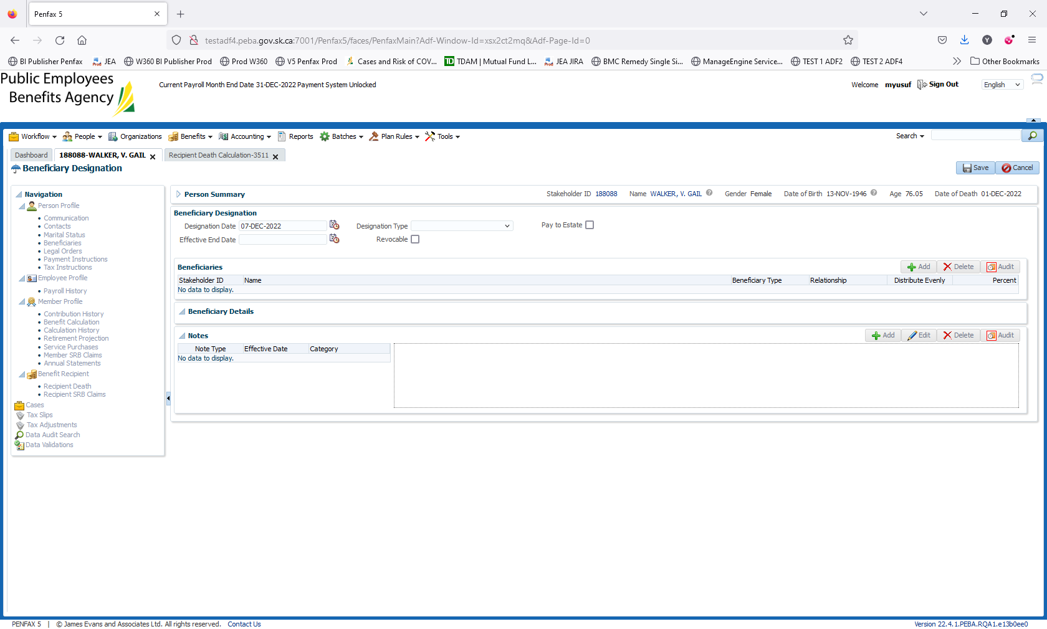

Enter the Designation Type: MEPP Pension Benefit

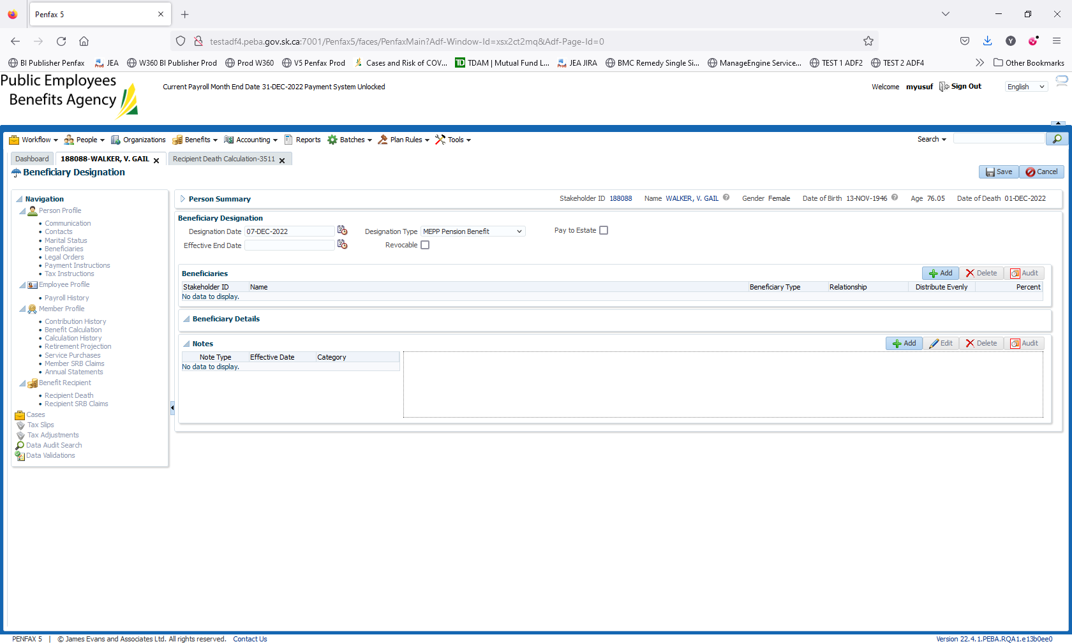

Beneficiaries ->Click on Add

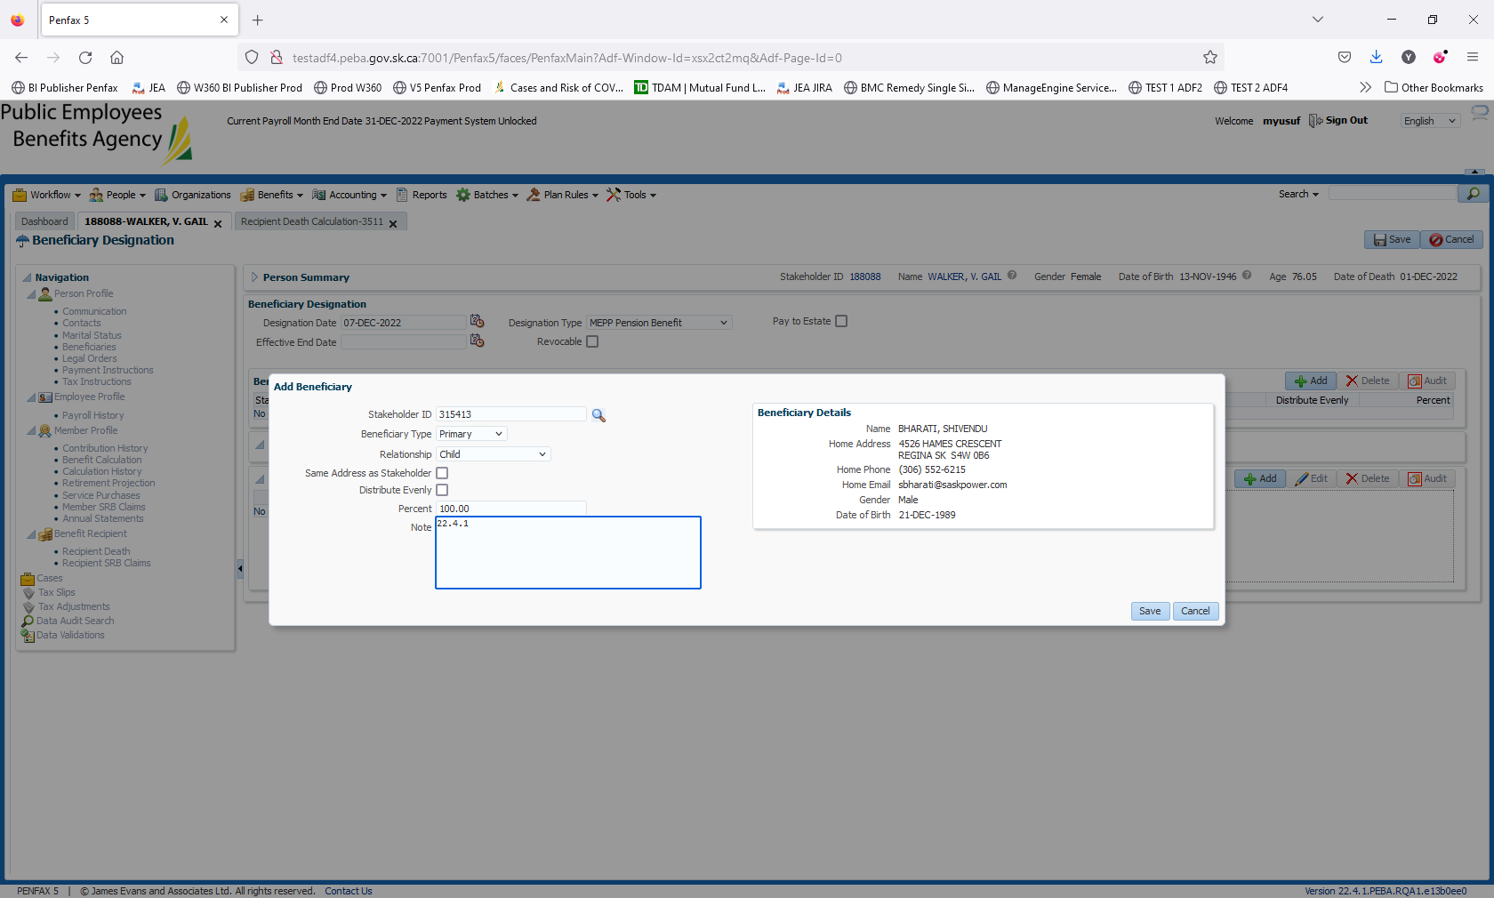

Changed the Child as primary beneficiary. Click on Save   
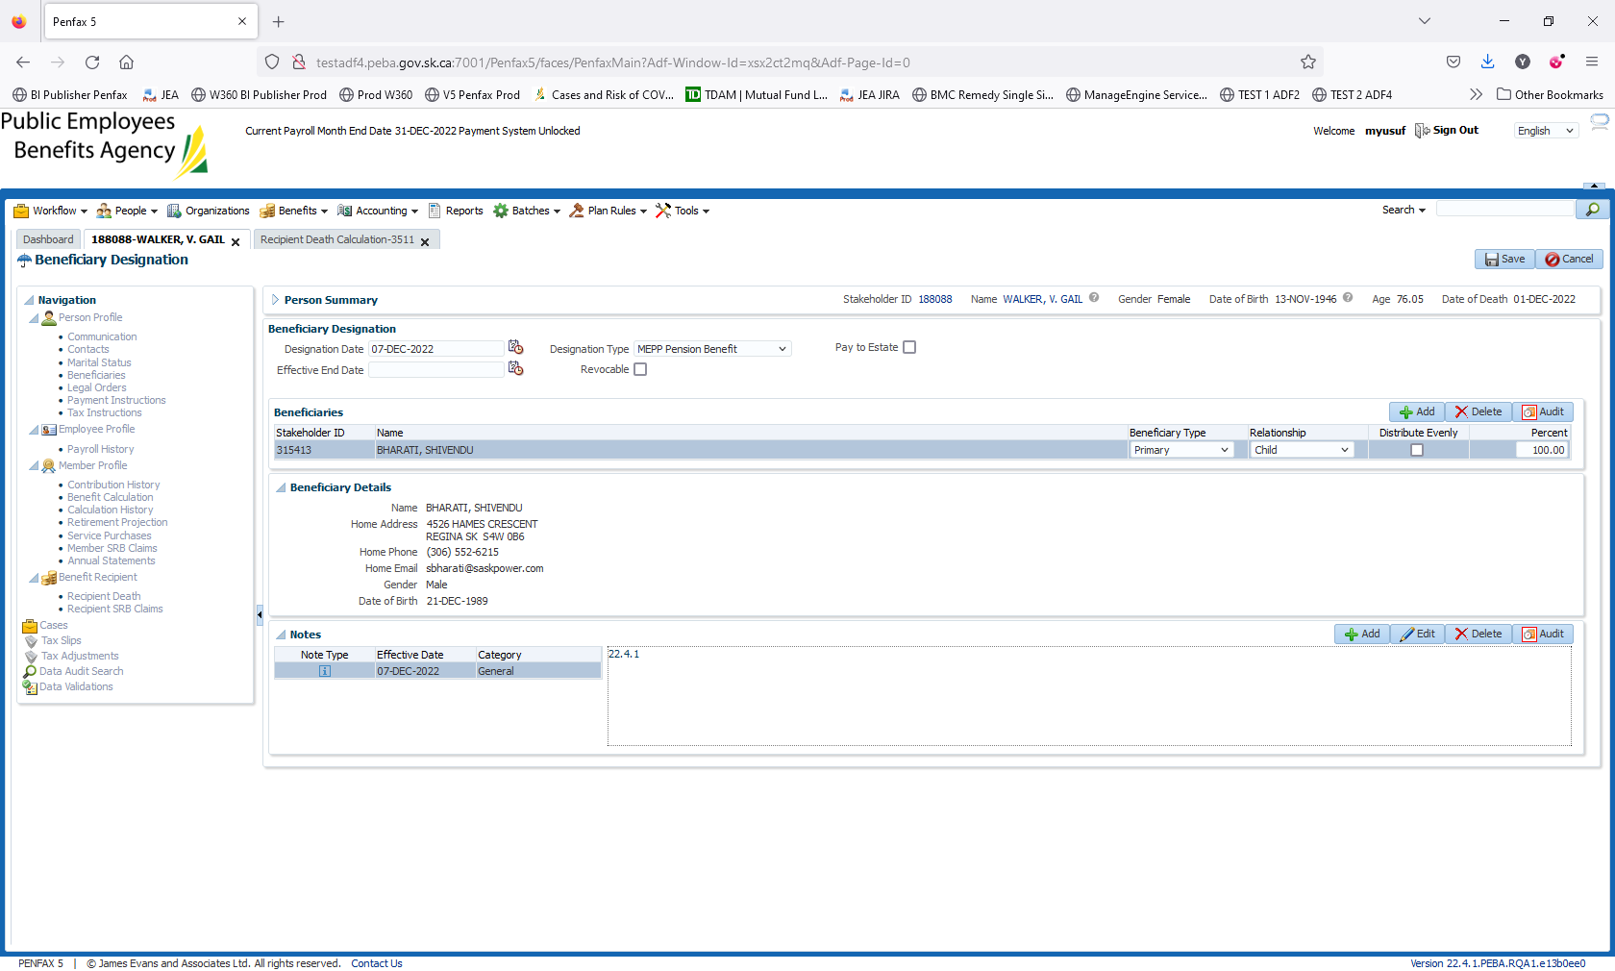   
Click on Save. Top right had corner

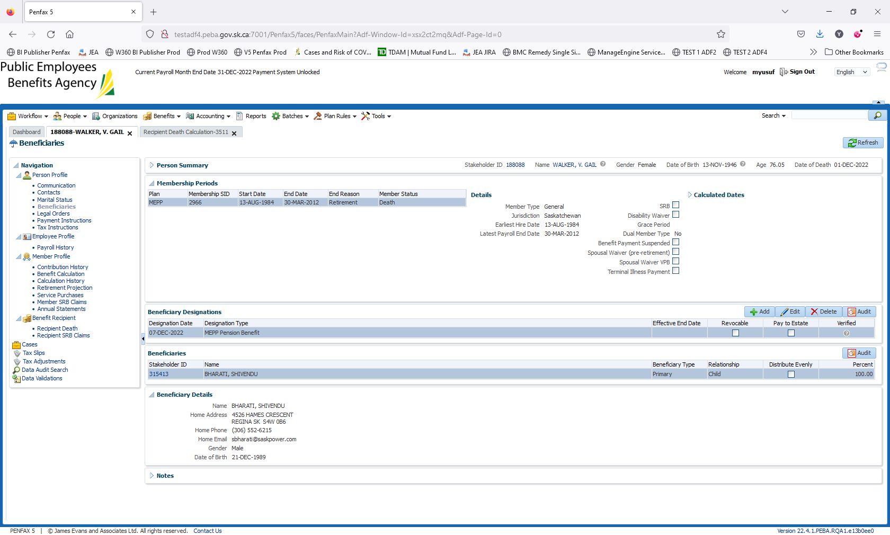

Added the child as a Beneficiary to receive income benefit.

